Chapter 6, Problem 64.

The switch in Fig. 6.86 has been in position A for a long time. At t = 0, the switch moves from position A to B. The switch is a make-before-break type so that there is no interruption in the inductor current. Find:

(a) i(t) for t > 0,
(b) v just after the switch has been moved to position B,
(c) v(t) long after the switch is in position B.

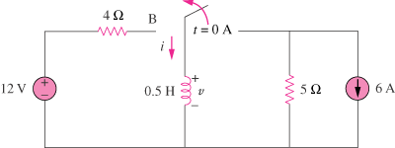

Figure 6.86
For Prob. 6.64.

